Collaboration Corner: Rethinking the IEP: Making Language the Foundation of Academics
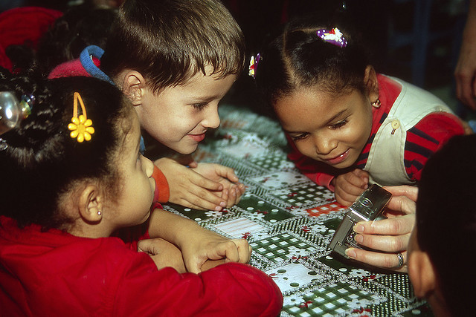
Collaboration Corner is a new monthly column written for ASHAsphere by Kerry J. Davis, E.d.D, CCC/SLP. Kerry will focus on different themes that involve collaborating with colleagues and other disciplines. Thank you Kerry for sharing your ideas with the ASHA community!
We welcome guest bloggers and columnists; if you’d like to write for ASHAsphere, please fill out a blogger application here.
I work in a totally inclusive school district as an inclusion speech-language pathologist. My caseload consists of the neediest students in the district. Those kids are simply fascinating to me. I work with the soup-to-nuts kids; kids with severe learning challenges, kids with social-emotional disabilities, kids who are nonverbal. You know the kids where you try and crawl inside their neurology and figure out how they perceive the world? These students push me to be a better clinician. More importantly, they make me want to think creatively on how to make public school and inclusion work for them.
All of my students participate in a general education classroom. Students attend their neighborhood schools and access their day with a host of academic supports. All of my students have goals that allow meaningful access to math, language arts, science and social studies. And here’s the funny part, while all of my students have communication disorders, I am working to eliminate the designated “speech and language” section of many students’ IEPs.
Imagine taking the speech and language section off of the IEP! I can sense the collective raising of eyebrows….
But here’s the deal. I believe that one of the best parts of being a speech-language pathologist is that opportunities for learning are never-ending. Language is everywhere. Bruner (1996) discussed the need to connect learning through meaningful interaction. People learn when they can relate new information with old information. Semantic-connections allow for learning. Language is the vehicle for that connection.
So let’s back up to the IEP. Why do we tend to compartmentalize language and communication to a single goal area? It is unnecessary, and dare I say…inappropriate.
Collaborative goal-writing
So perhaps we should rethink our approach. A student’s IEP is based upon the team’s recommendations.
Integrating language-based goals throughout the IEP also encourages team ownership. Distributing language-based objectives throughout the IEP underscores the connection between language and academics. For students who need extra repetition and meaningful practice across contexts, these collaborative efforts foster skill generalization. So how does that look in an IEP? Here are some ideas my school-based teams have used (as a part of measurable objectives of course):
Math:
- Develop the concepts of less, more, some
- Answering wh-questions related to quantity
- Following directions in a recipe, including gathering appropriate tools and materials
Science:
- Provide similarities and differences(feature/function/class) between target vocabulary words
  - simple machines
  - animals and habitats
  - weather
  - states of matter
- Using temporal markers, will demonstrate understanding of a plant/animal life cycle
- Answering wh-questions related to non-fiction text and picture books
Social studies/geography:
- Matching clothing with seasons
- Using attributes to describe the weather
- Identifying and answering personal and biographical information (town, street, school)
- From a book or activity, answer who, where, what doing, and when questions related to other countries and communities
English Language Arts:
- Answering wh-questions related to character, setting and supporting events
- Using temporal markers to create a personal narrative from a photograph
- Use a home journal template to retell a two activities of the day
- From a photo, use adjectives to describe an event or activity
- Sequence pictures representing events from a picture book
Independence:
- Communicating self-advocacy,
- Asking clarifying questions,
- Following checklists related to daily routines,
- Following 2-step group directions
Some words of advice
I’ve used these ideas with children who have a variety of skill abilities. I use these ideas with children who have moderate to severe cognitive and communication challenges. Many use high-tech assistive technology tools, to accomplish these goals. Others use fill-in-the-blank cut and paste activities. The key is to scaffold the concepts in a way that will be meaningful. This does not mean lowering the bar for learning, these means thinking about how to embed naturalistically these ideas throughout the school day. Checklists can be used as part of getting ready in the morning. Narrative writing may include templates and photographs, or writing a letter home at the end of the day. Sequencing can be used in “how-to” books, or describing the life cycle of a frog. Comparisons can be drawn between a student’s home, and the Native American Wetu. All of these examples connect language concepts and learning in a meaningful way.
Gather the expertise in your team members and make the IEP work for those students that challenge you; you will be better practitioner for it. Not every team will be ready for this change. Through thoughtful discussion, creative planning and patience, the shift may not be as hard as you think.
References:
Bruner, J. (1996). The culture of education. Cambridge, MA: Harvard University Press.
Dr. Kerry Davis is a city-wide speech-language pathologist in the Boston area. Her area of interest includes augmentative alternative communication, and working with children with multiple disabilities and learning challenges. I welcome various perspectives and lively dialogue. The views on this blog are my own and do not represent those of my employer. Dr. Davis can be followed on Twitter at @DrKDavisslp.

